Watch
# Source: AI Source: Provided by: [Data Path: Persons Table -> ID Column: 1, Name_En Column: Motasem Essam] -> From: [ChatGPT] on [7/17/2026]
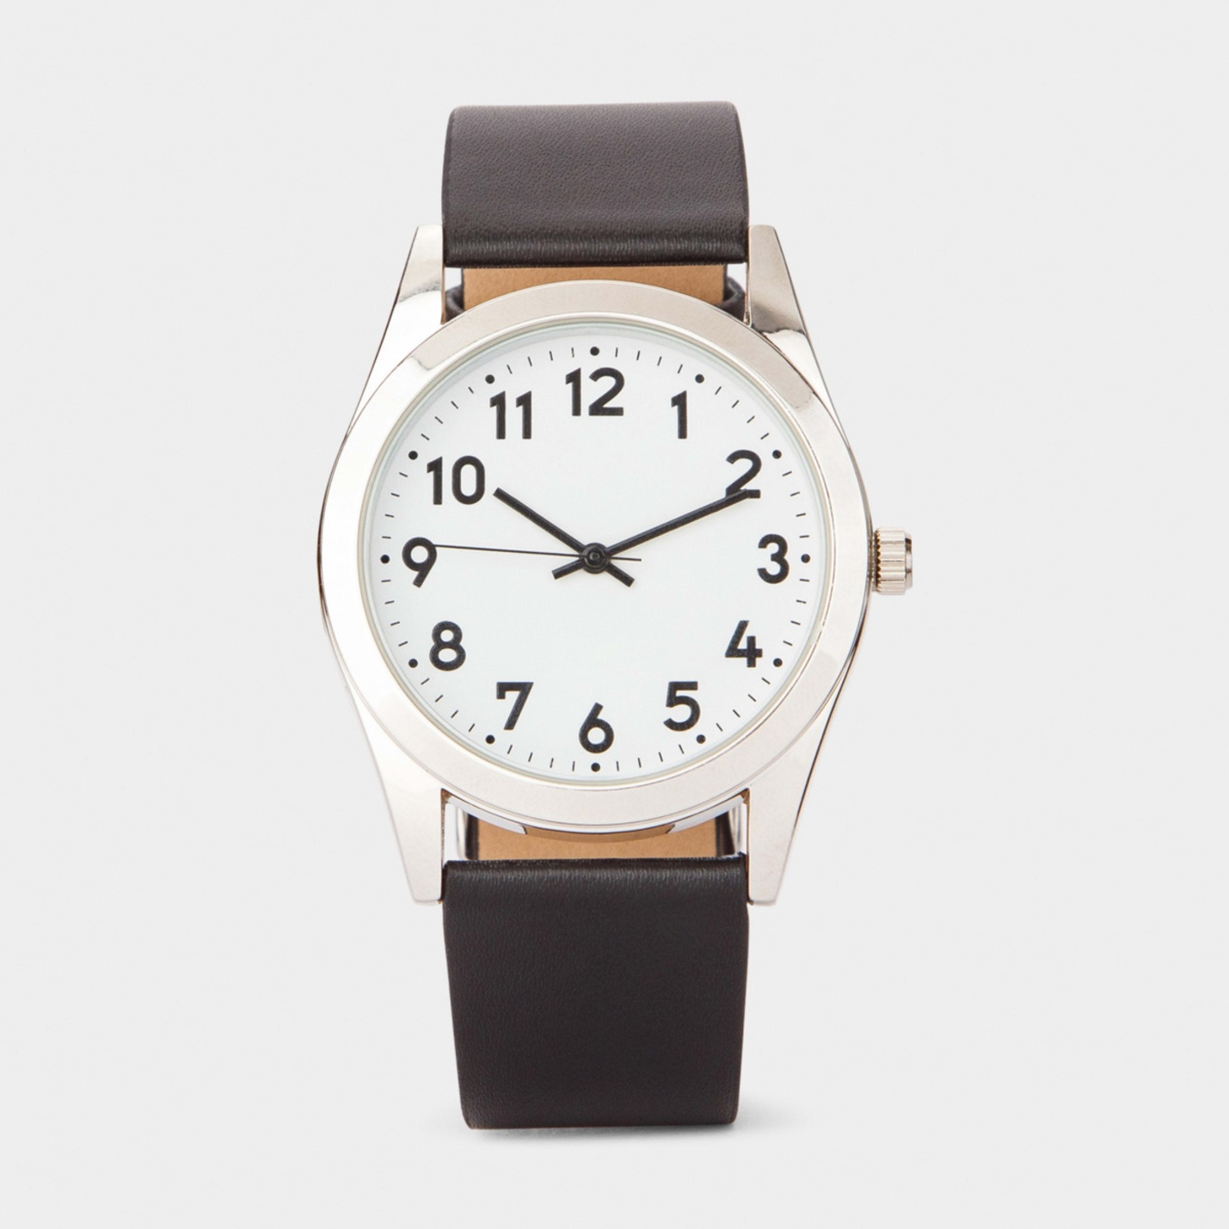
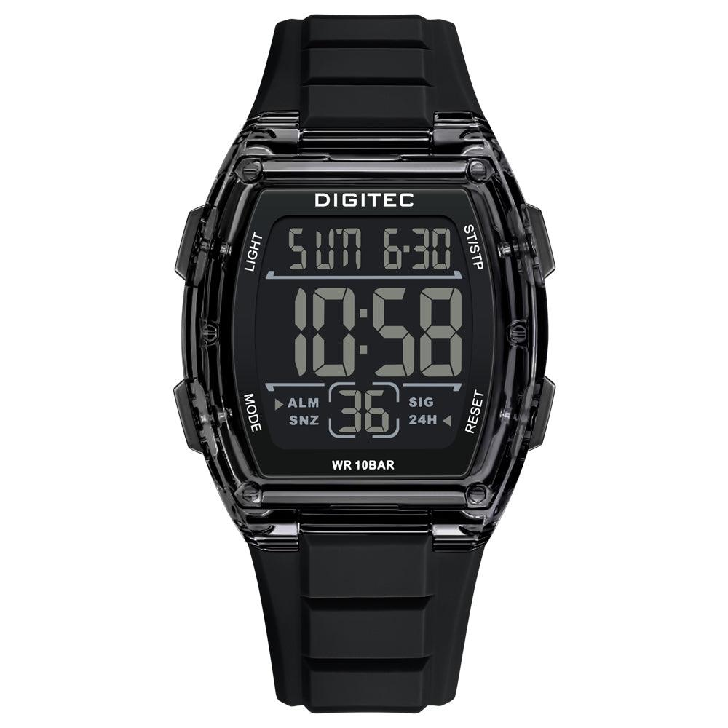
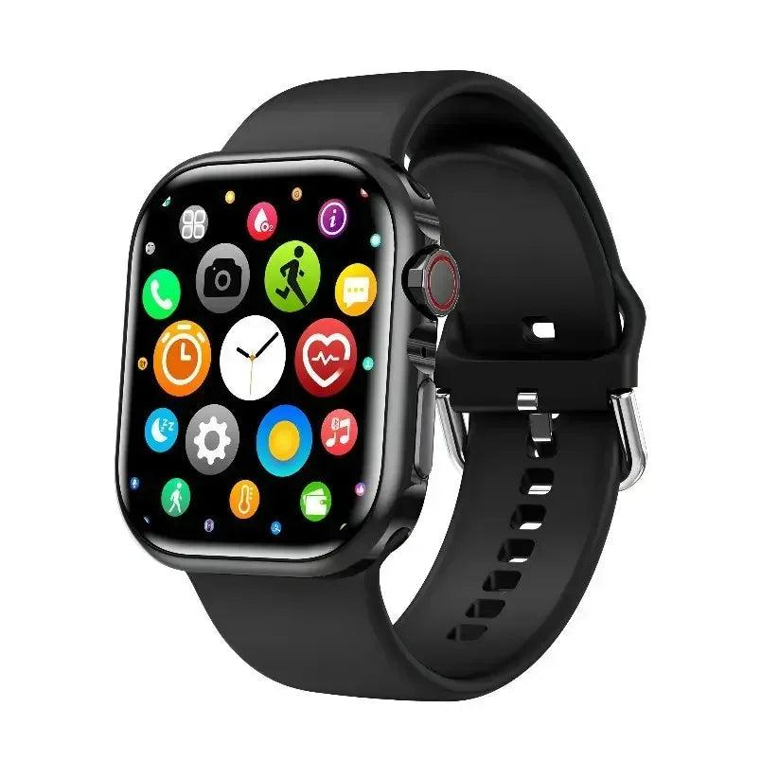
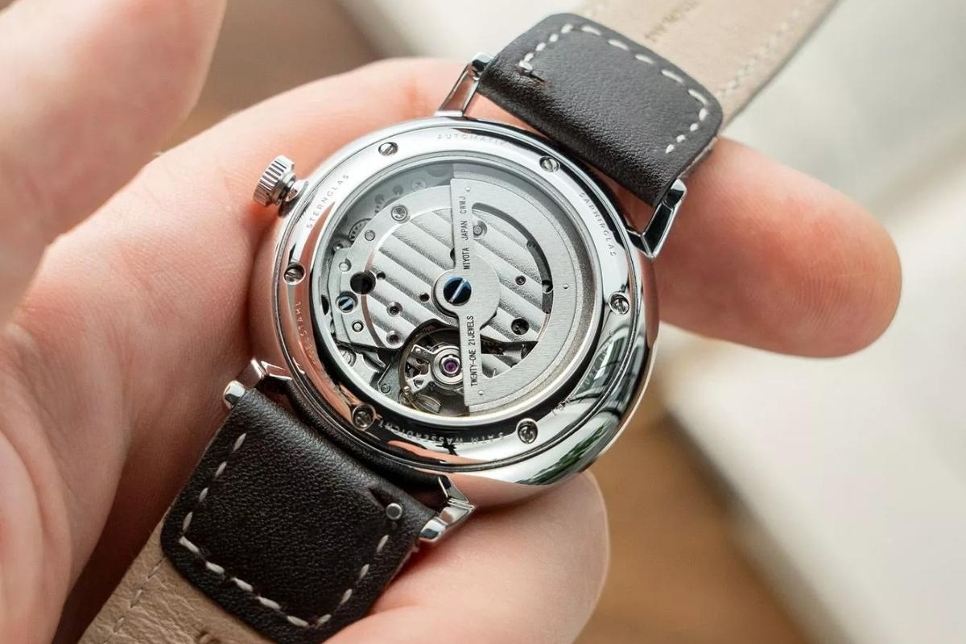
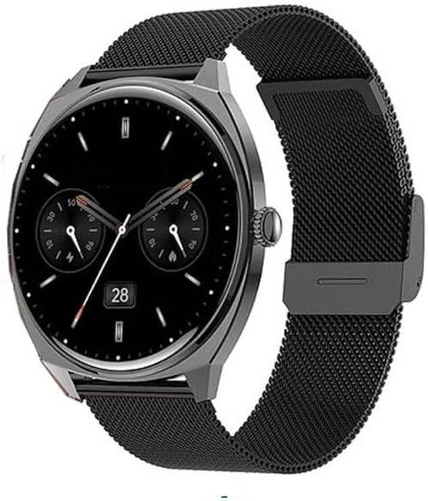
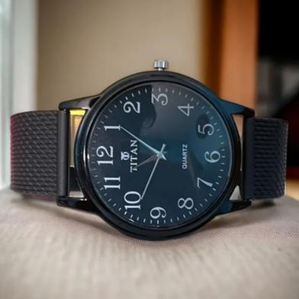
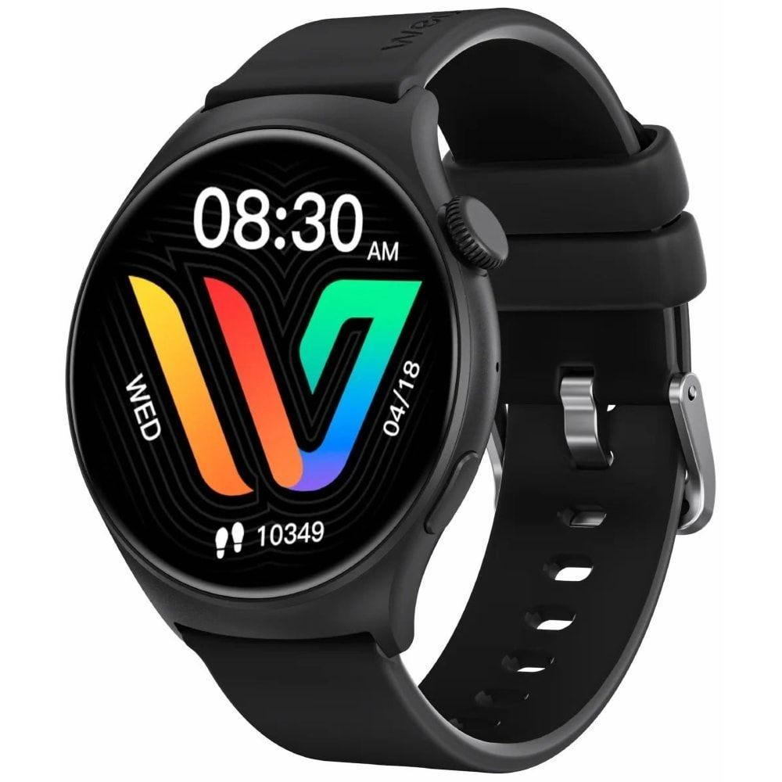
A Watch is a portable time-measuring instrument designed to be worn on the wrist or carried on the body. It continuously measures and displays the current time, allowing the user to monitor time conveniently anywhere.
Modern watches range from simple analog wristwatches to advanced smartwatches capable of monitoring health, navigation, communication, and fitness.

Definition
# Source: AI Source: Provided by: [Data Path: Persons Table -> ID Column: 1, Name_En Column: Motasem Essam] -> From: [ChatGPT] on [7/17/2026]
A Watch is a portable time-measuring instrument worn on the wrist or carried by a person, designed to continuously measure and display the current time.

Purpose
# Source: AI Source: Provided by: [Data Path: Persons Table -> ID Column: 1, Name_En Column: Motasem Essam] -> From: [ChatGPT] on [7/17/2026]
A watch is used to:
- Display the current time.
- Keep personal schedules.
- Measure short time intervals (some models).
- Set alarms and reminders.
- Track dates and calendars.
- Monitor health and fitness (smartwatches).
- Support navigation and communication (advanced models).

Principle of Operation
# Source: AI Source: Provided by: [Data Path: Persons Table -> ID Column: 1, Name_En Column: Motasem Essam] -> From: [ChatGPT] on [7/17/2026]
The operating principle depends on the watch type:
- Mechanical watches use a mainspring, gears, escapement, and balance wheel.
- Quartz watches use a quartz crystal oscillator powered by a battery.
- Digital watches use electronic circuits with a quartz oscillator and LCD/LED display.
- Smartwatches combine quartz timing with microprocessors, sensors, wireless communication, and rechargeable batteries.

Main Components
# Source: AI Source: Provided by: [Data Path: Persons Table -> ID Column: 1, Name_En Column: Motasem Essam] -> From: [ChatGPT] on [7/17/2026]
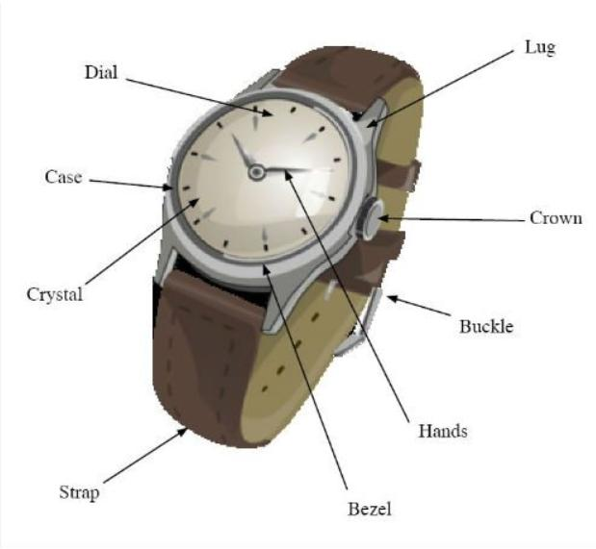
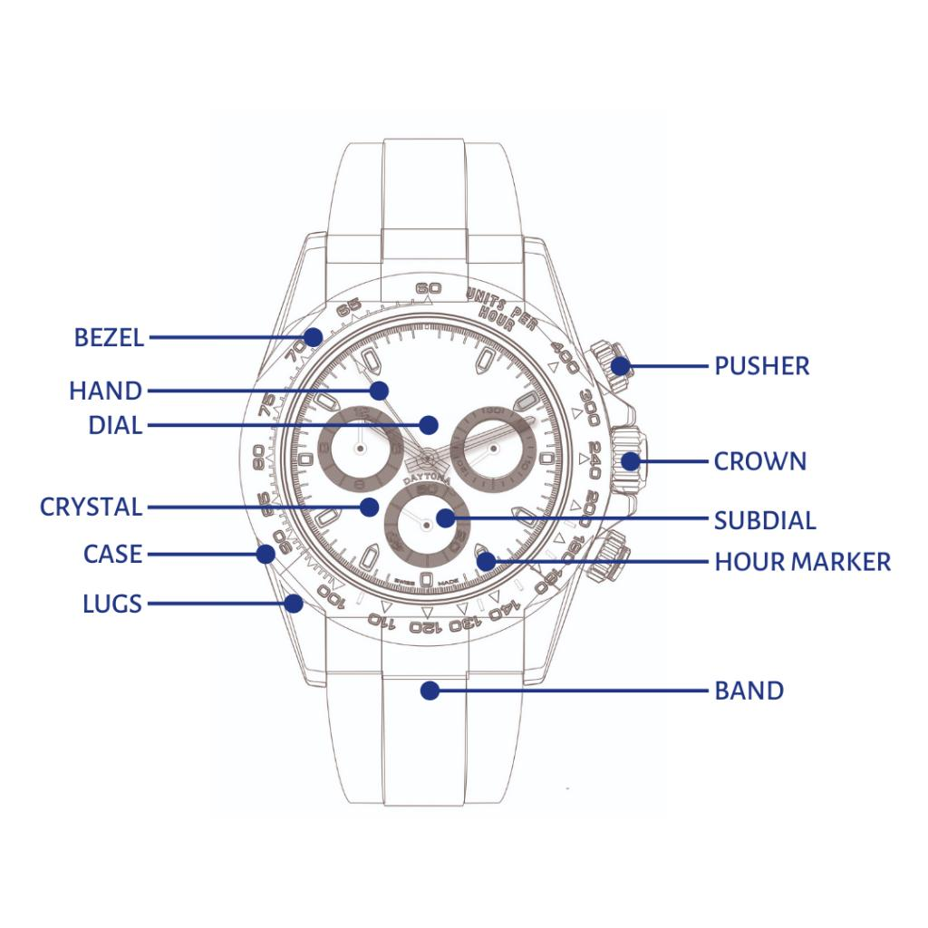
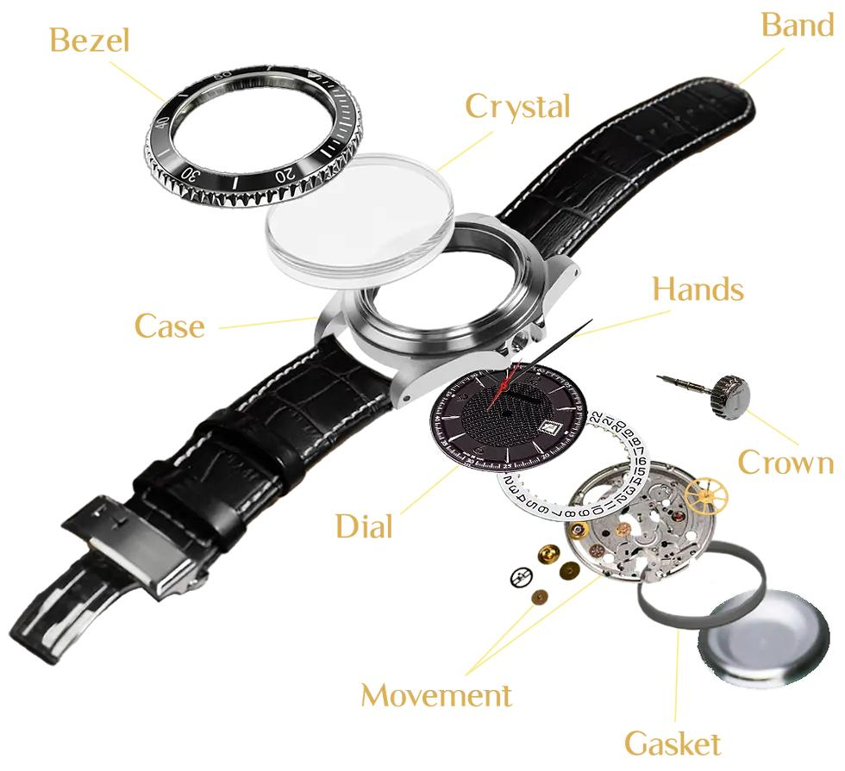
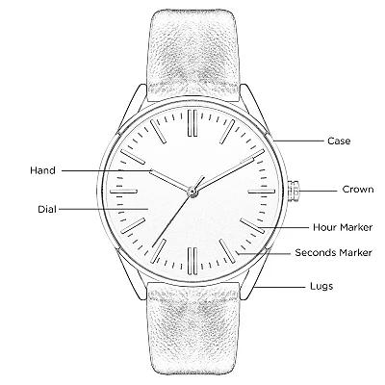
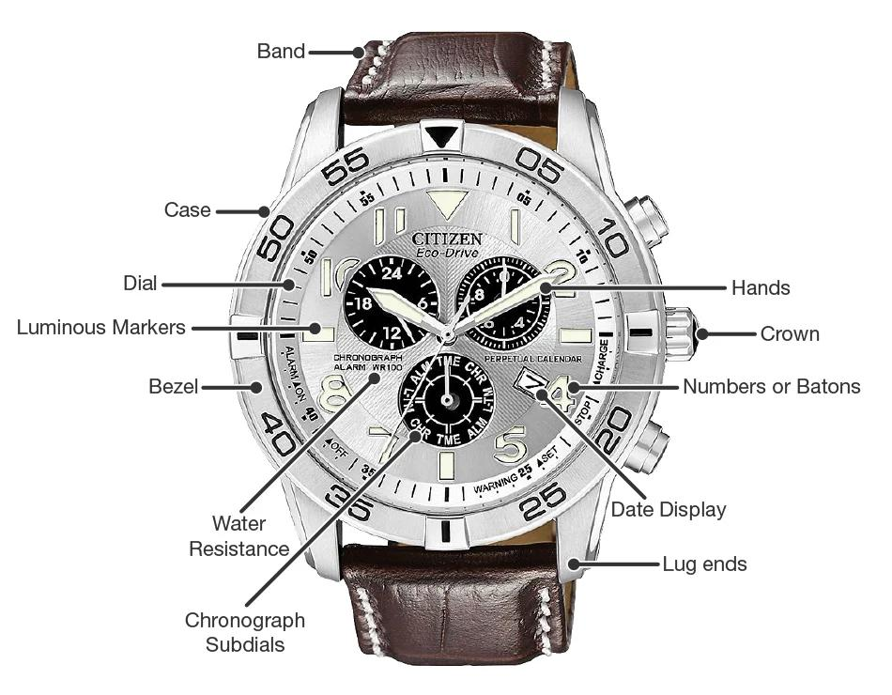
A typical watch consists of:
- Case
- Crystal (glass)
- Dial or display
- Hour hand
- Minute hand
- Second hand (analog models)
- Crown or adjustment buttons
- Strap or bracelet
- Internal movement (mechanical or quartz)
- Battery or mainspring

Types of Watches

1. Analog Watch
# Source: AI Source: Provided by: [Data Path: Persons Table -> ID Column: 1, Name_En Column: Motasem Essam] -> From: [ChatGPT] on [7/17/2026]

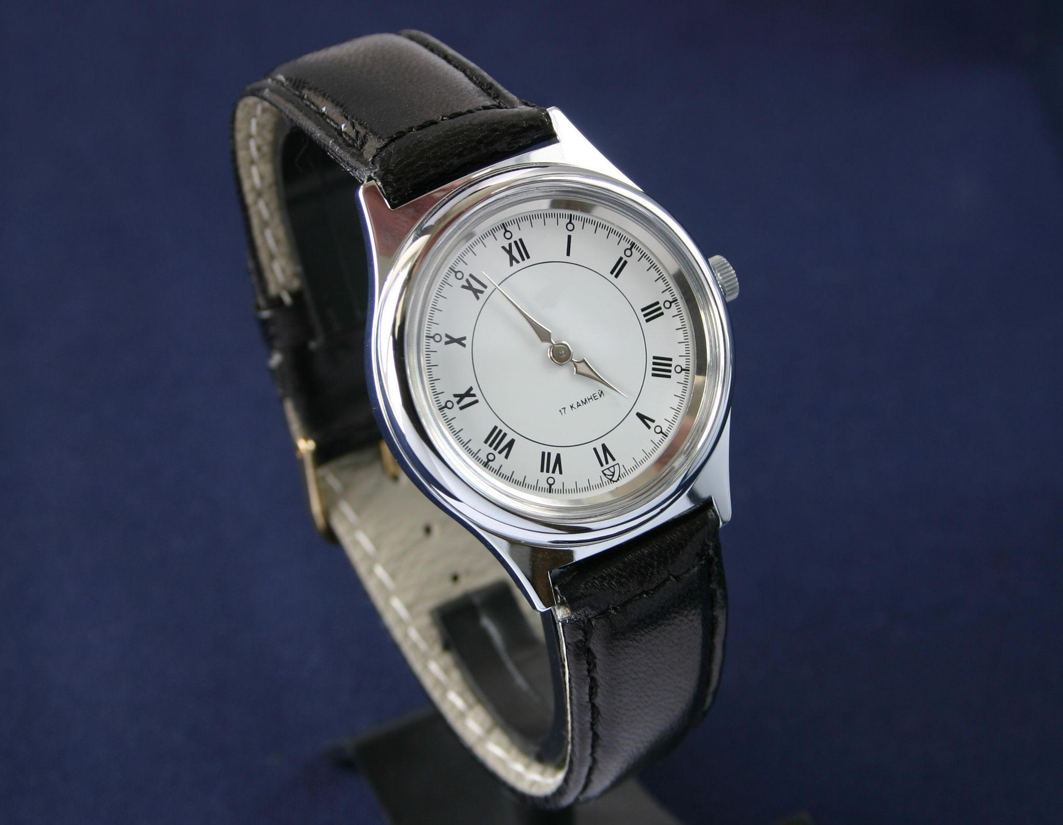
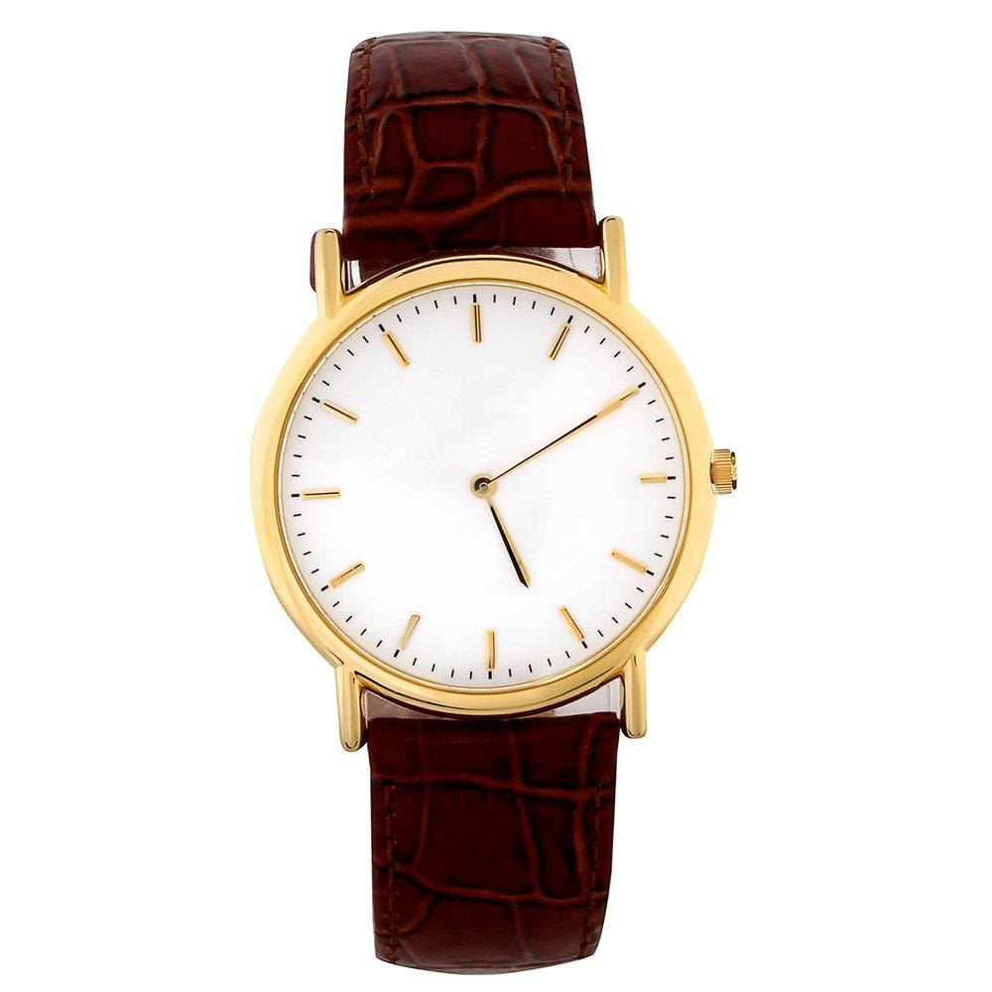
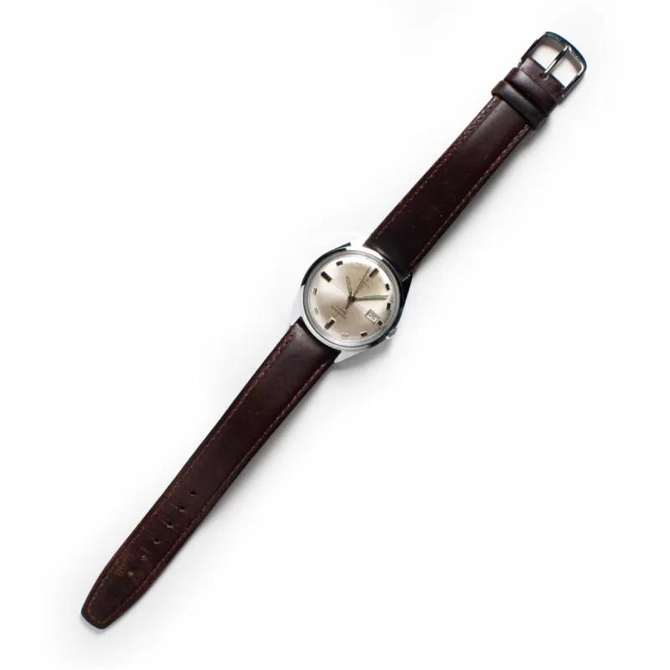
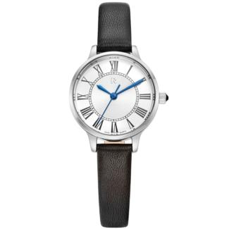
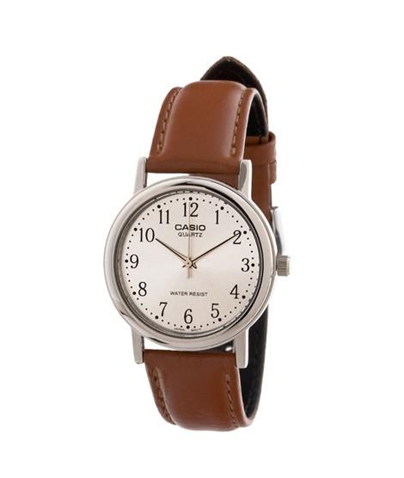
Description
Displays time using rotating hands over a numbered or marked dial.
Features
- Hour hand
- Minute hand
- Second hand
- Elegant design
Applications
- Everyday use
- Business
- Formal occasions

2. Digital Watch
# Source: AI Source: Provided by: [Data Path: Persons Table -> ID Column: 1, Name_En Column: Motasem Essam] -> From: [ChatGPT] on [7/17/2026]
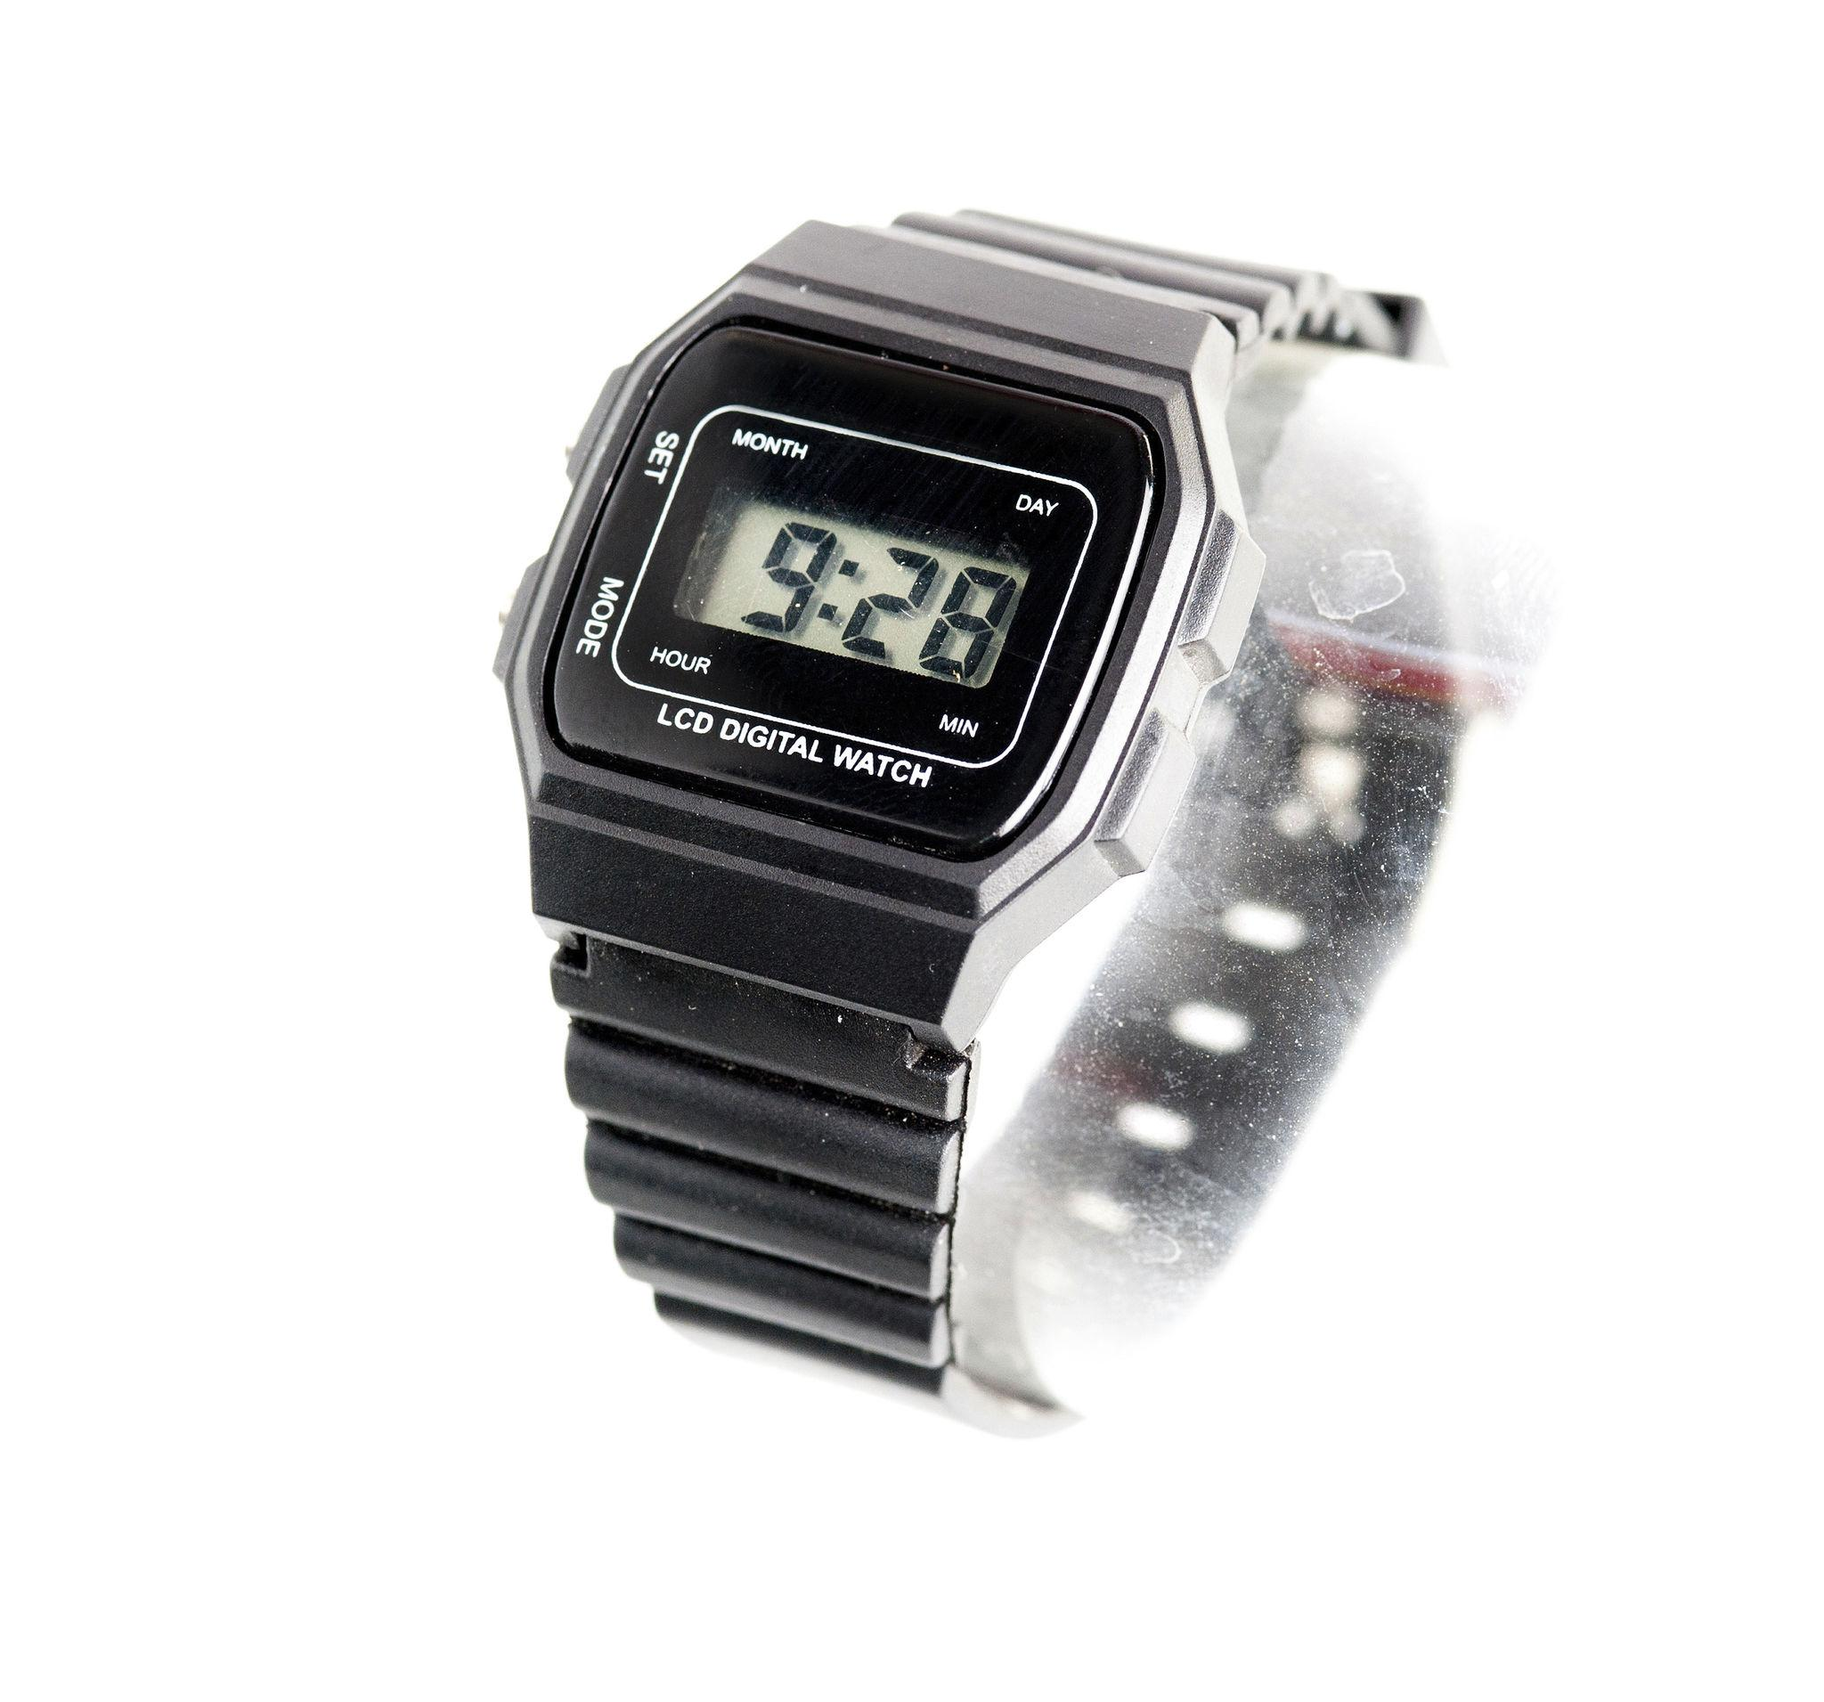
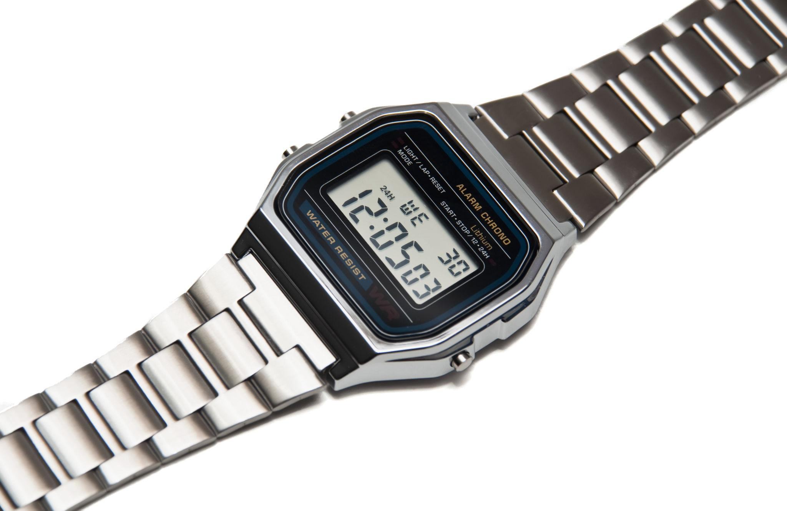
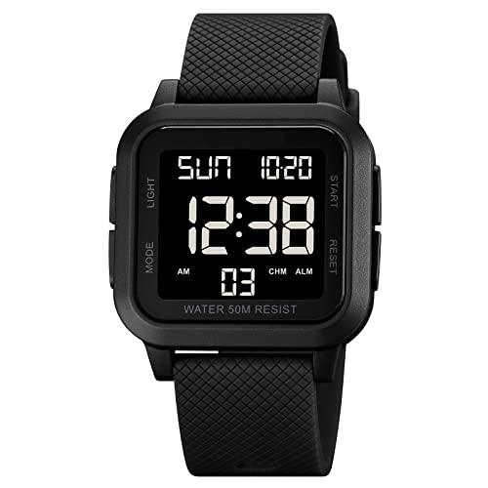
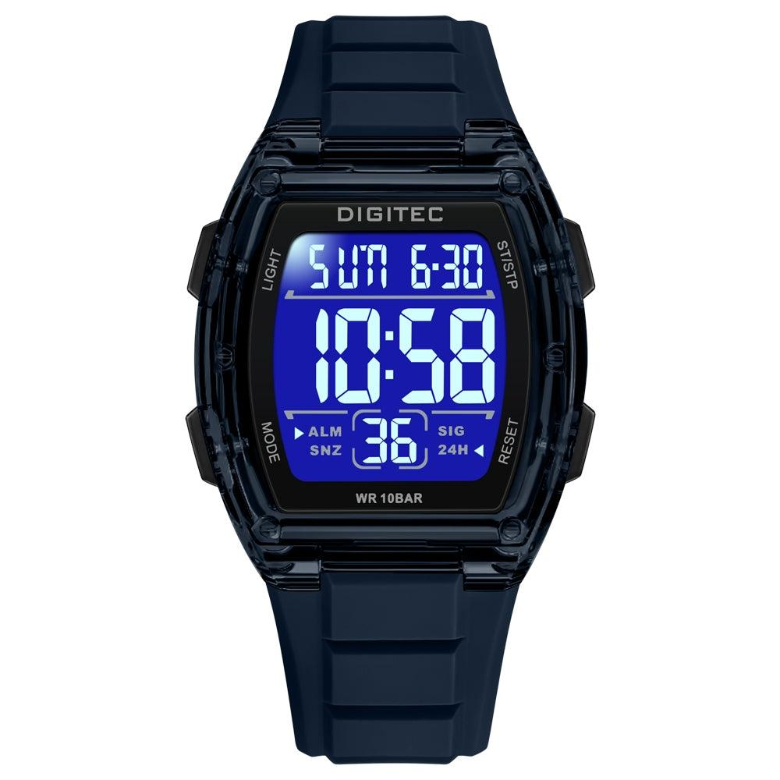
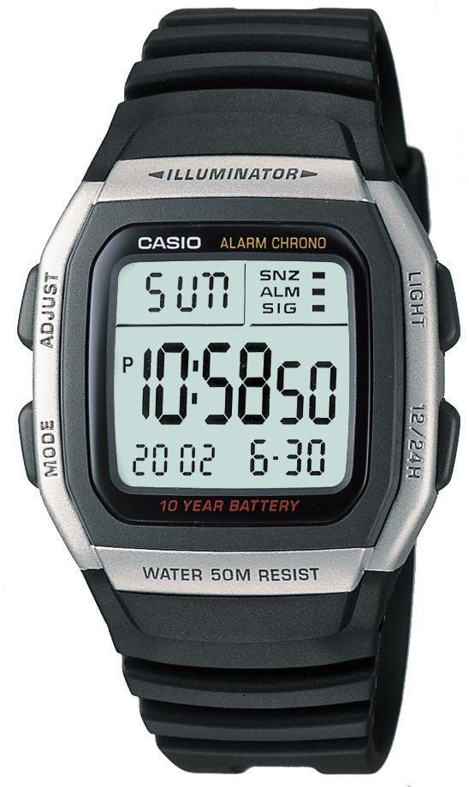
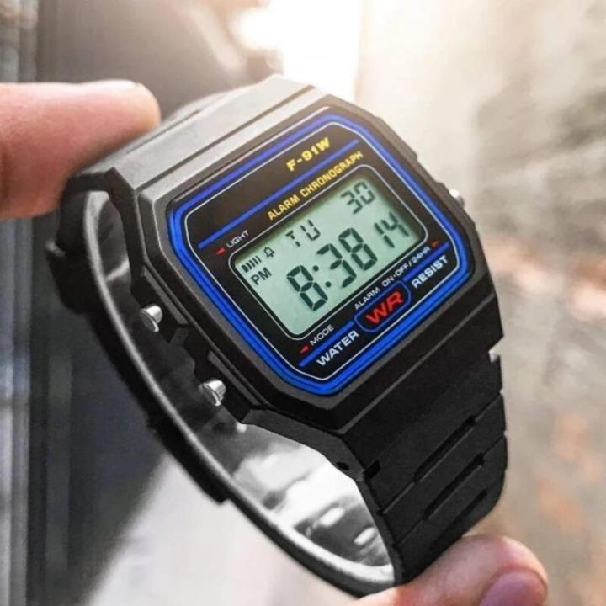
Description
Displays time numerically using an LCD or LED screen.
Features
- 12-hour or 24-hour display
- Stopwatch
- Alarm
- Calendar
- Backlight
Applications
- Sports
- Outdoor activities
- Daily use

3. Mechanical Watch
# Source: AI Source: Provided by: [Data Path: Persons Table -> ID Column: 1, Name_En Column: Motasem Essam] -> From: [ChatGPT] on [7/17/2026]
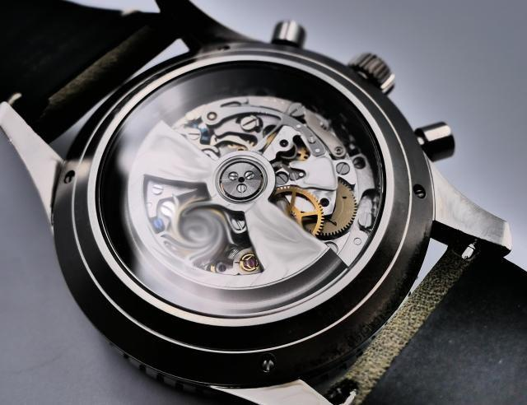

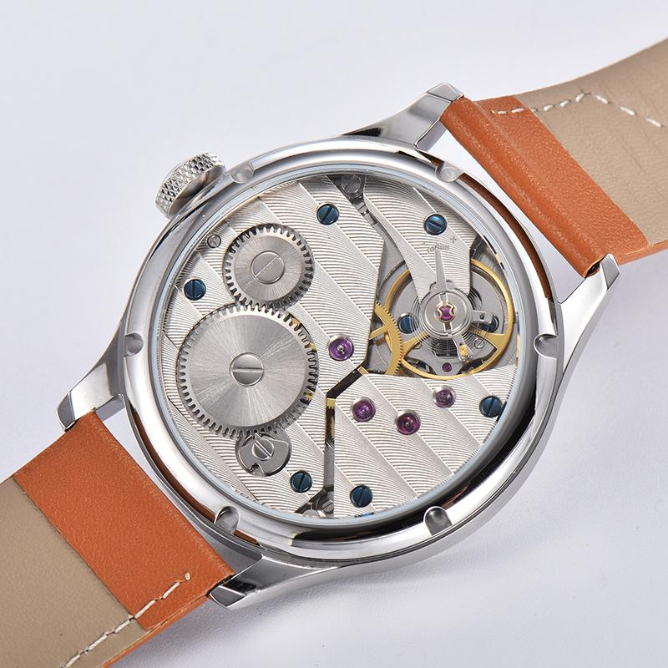
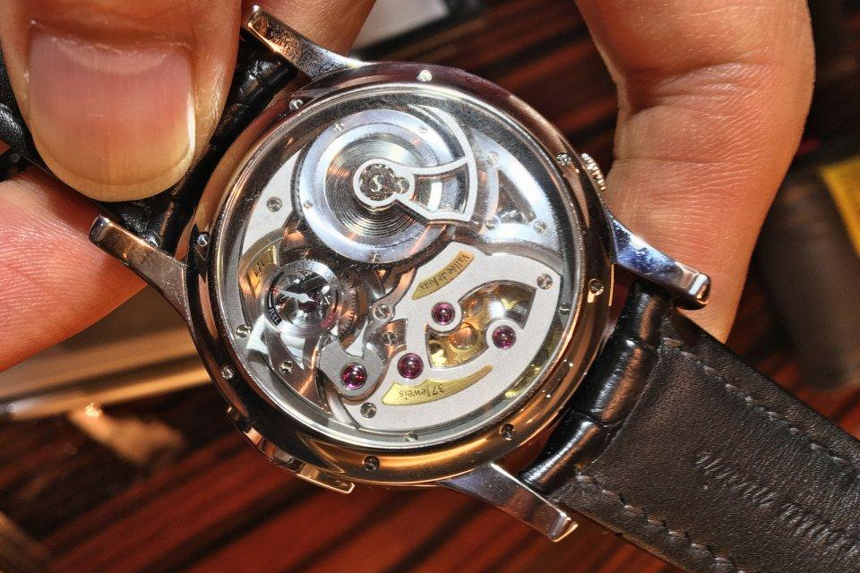
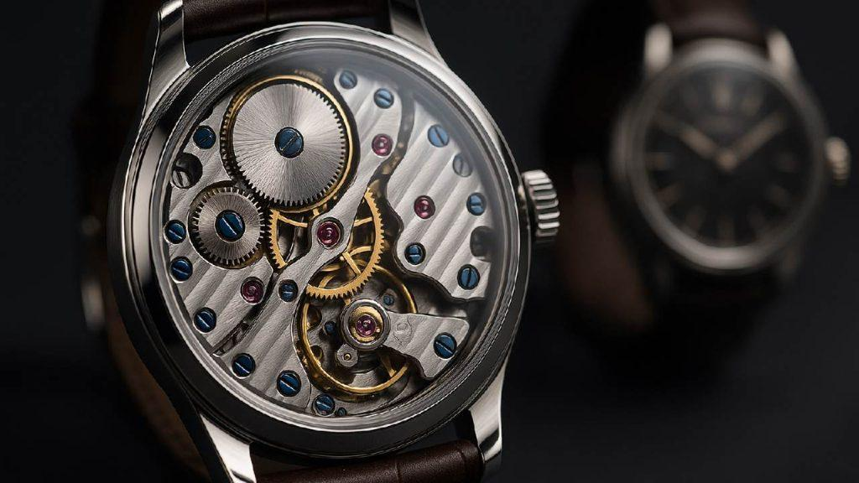
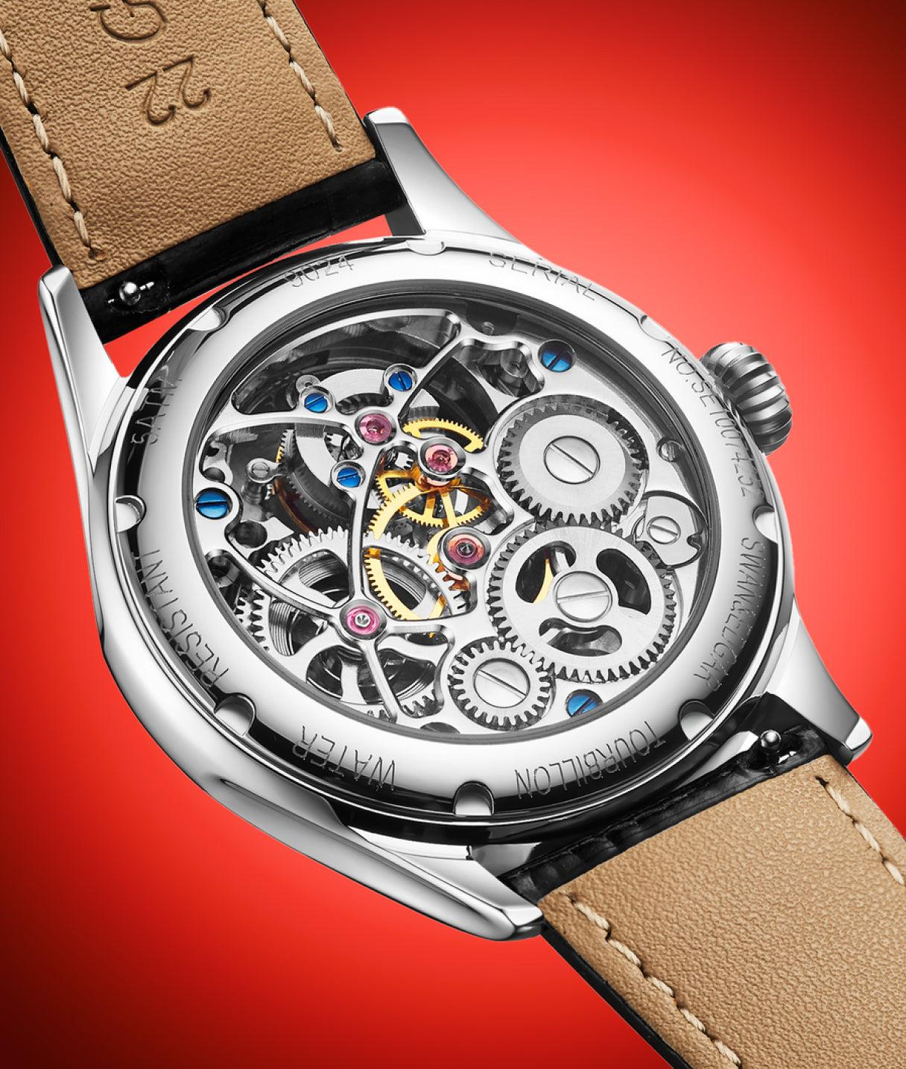
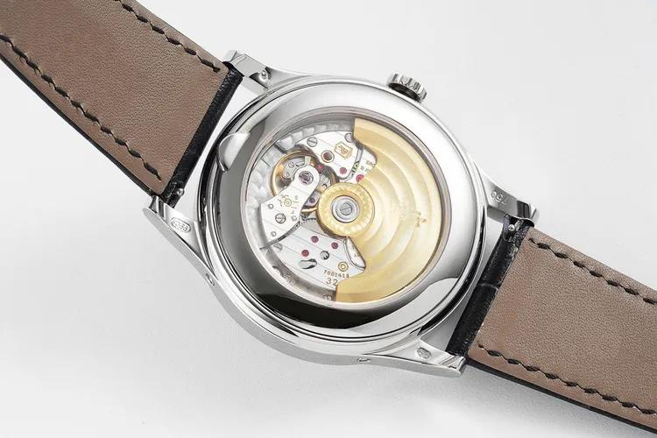
Description
Uses a spring-driven mechanical movement.
Features
- No battery
- Requires winding (manual) or automatic movement
- Traditional craftsmanship
Applications
- Luxury watches
- Collecting
- Formal wear

4. Quartz Watch
# Source: AI Source: Provided by: [Data Path: Persons Table -> ID Column: 1, Name_En Column: Motasem Essam] -> From: [ChatGPT] on [7/17/2026]
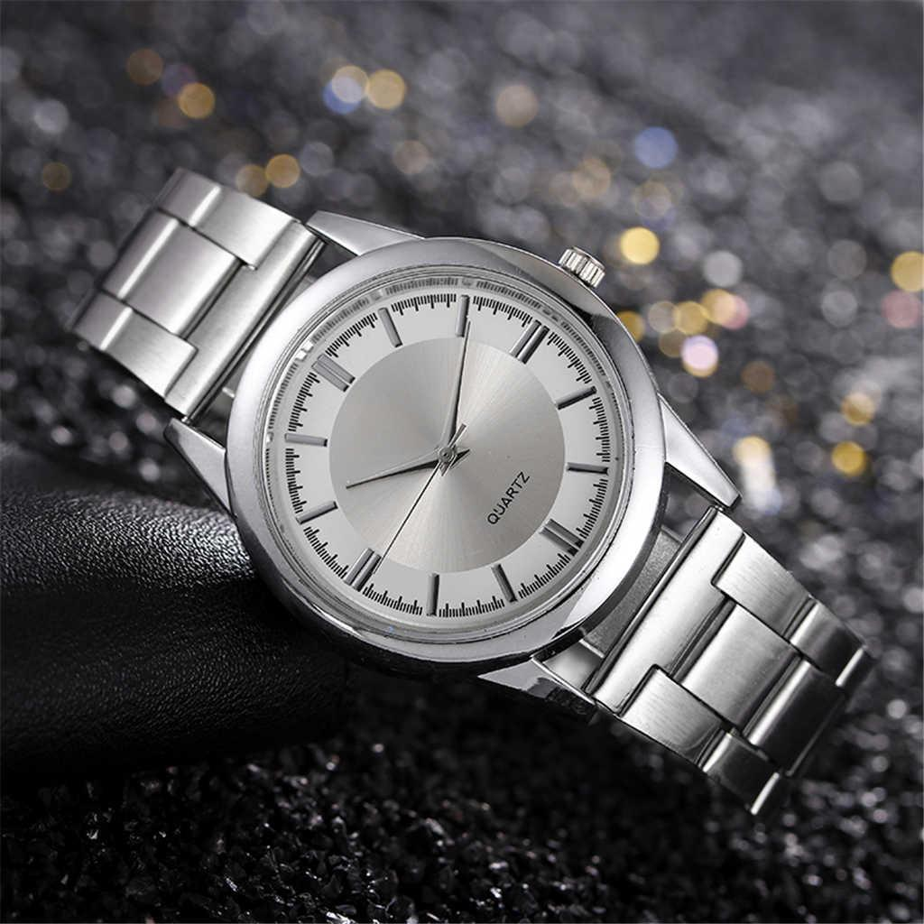
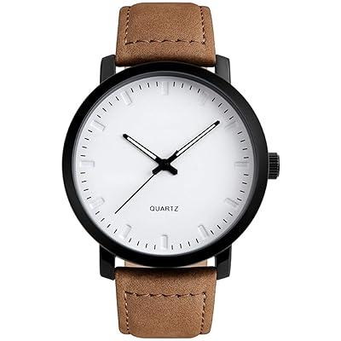
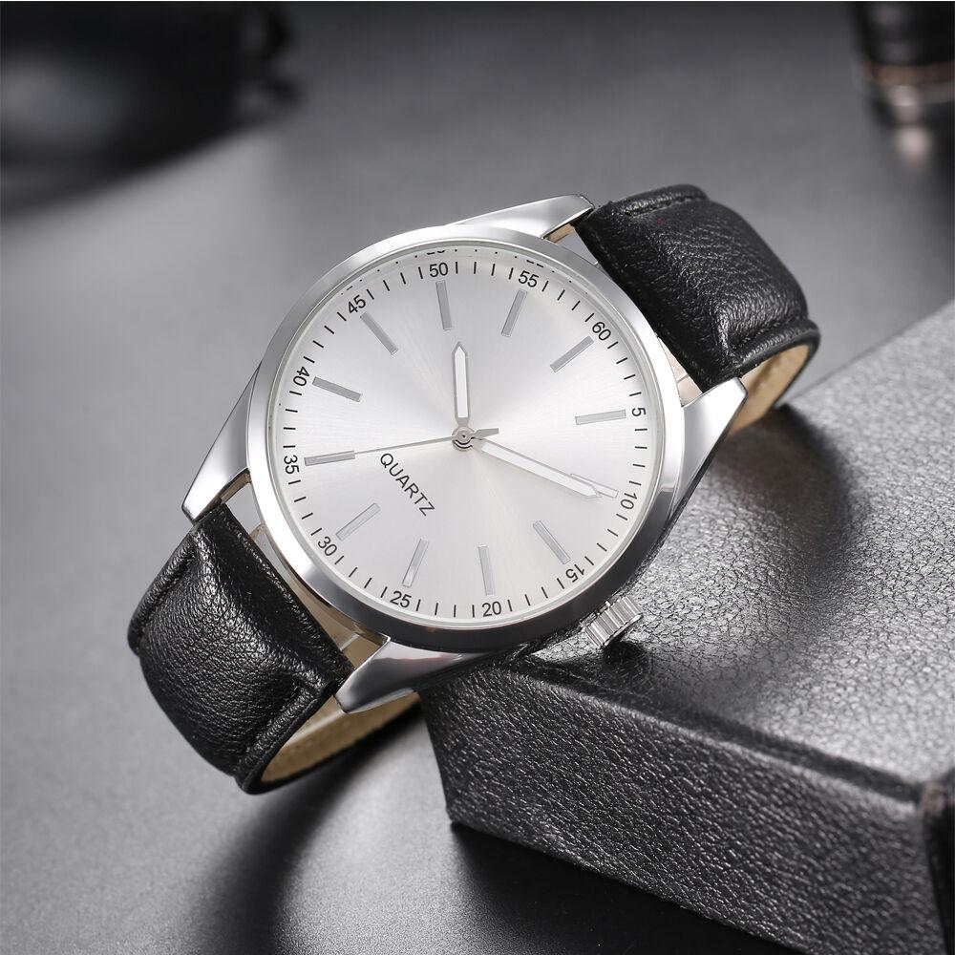
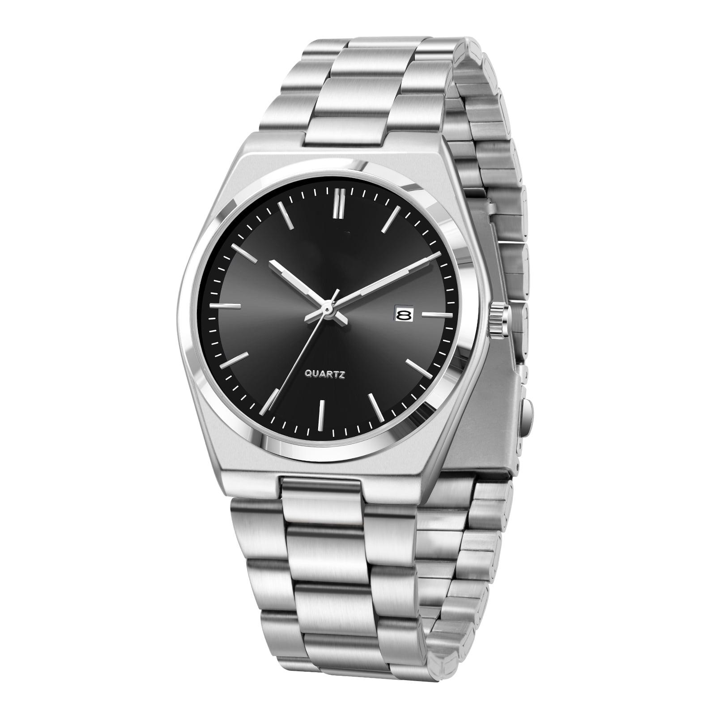
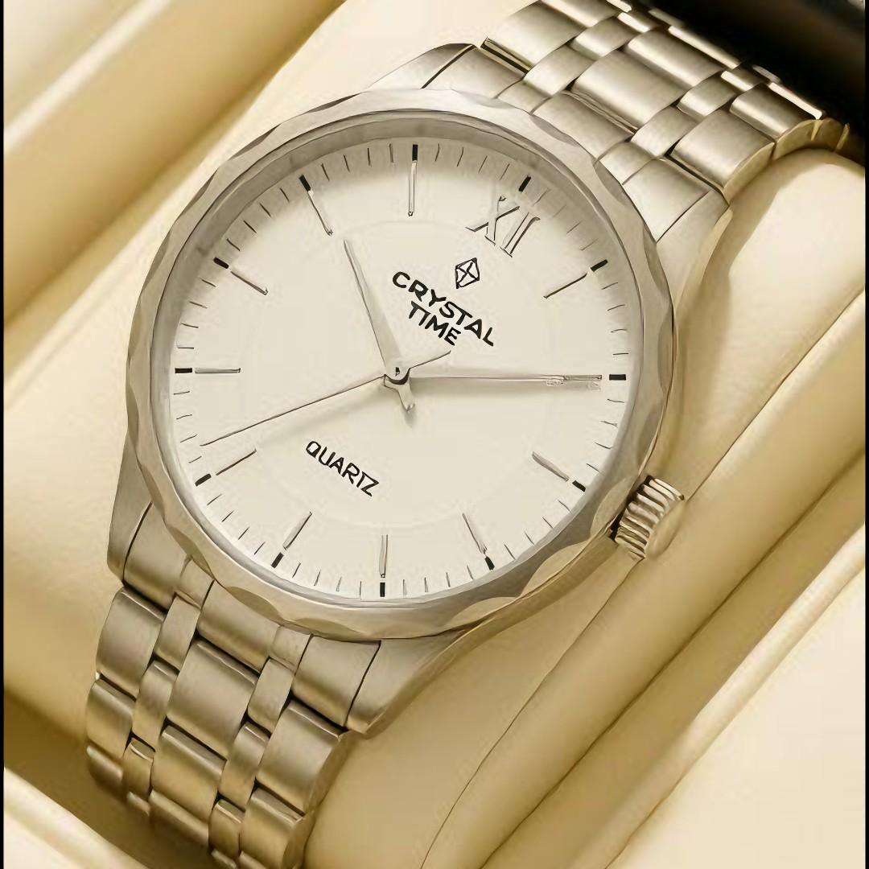
Description
Uses a quartz crystal oscillator powered by a battery.
Features
- High accuracy
- Low maintenance
- Affordable
Applications
- Everyday use
- Business
- Education

5. Smartwatch
# Source: AI Source: Provided by: [Data Path: Persons Table -> ID Column: 1, Name_En Column: Motasem Essam] -> From: [ChatGPT] on [7/17/2026]
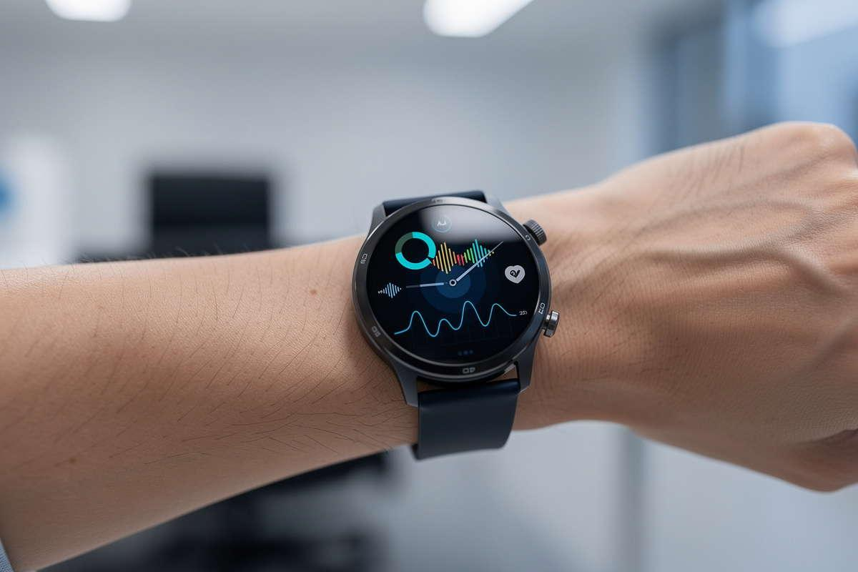
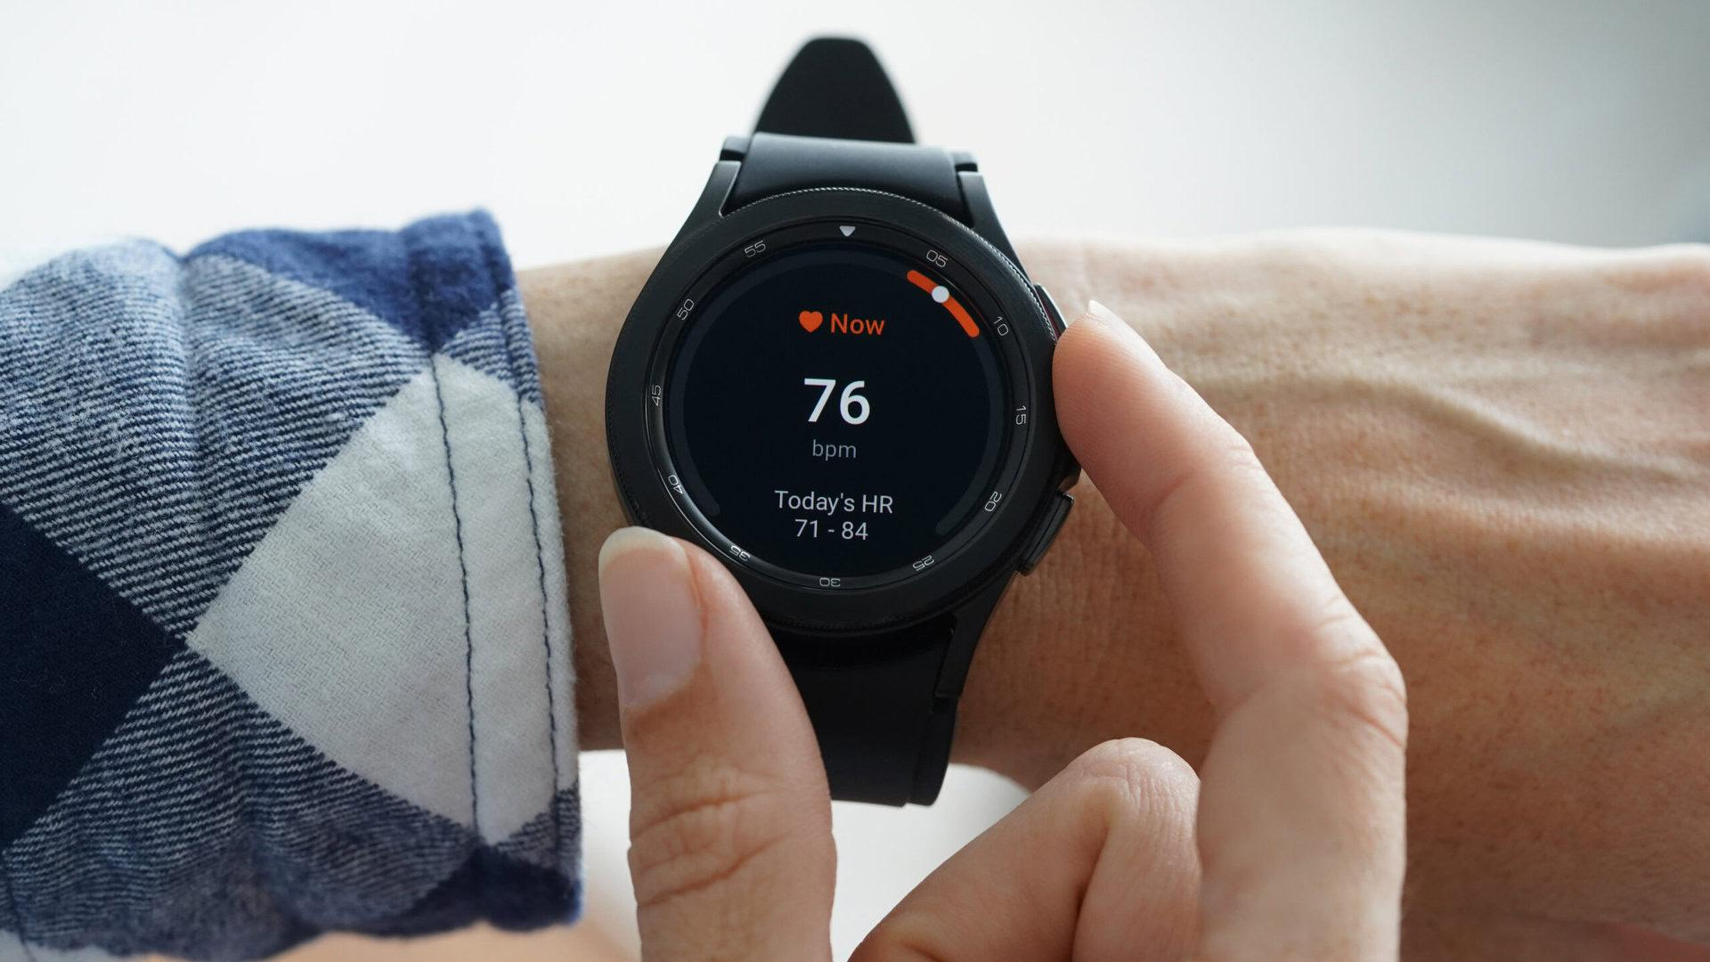
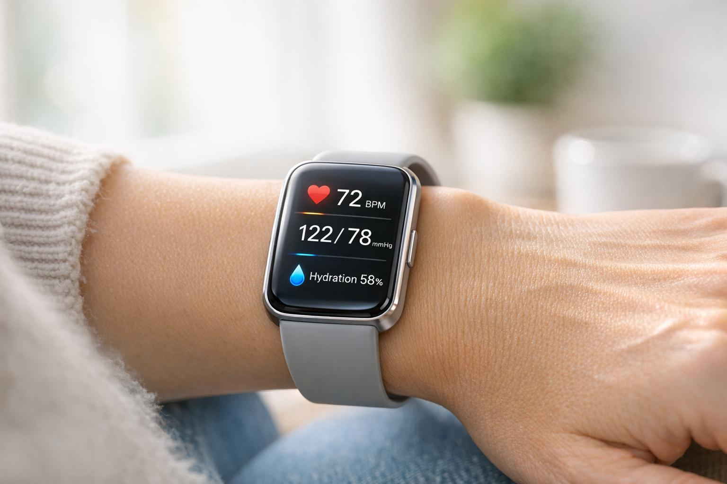
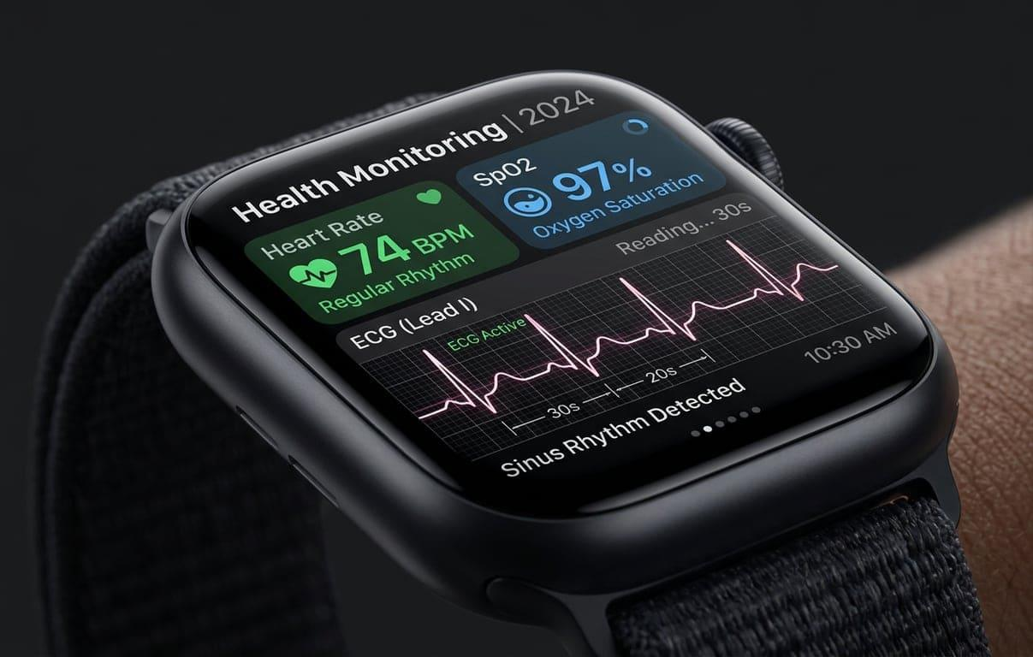
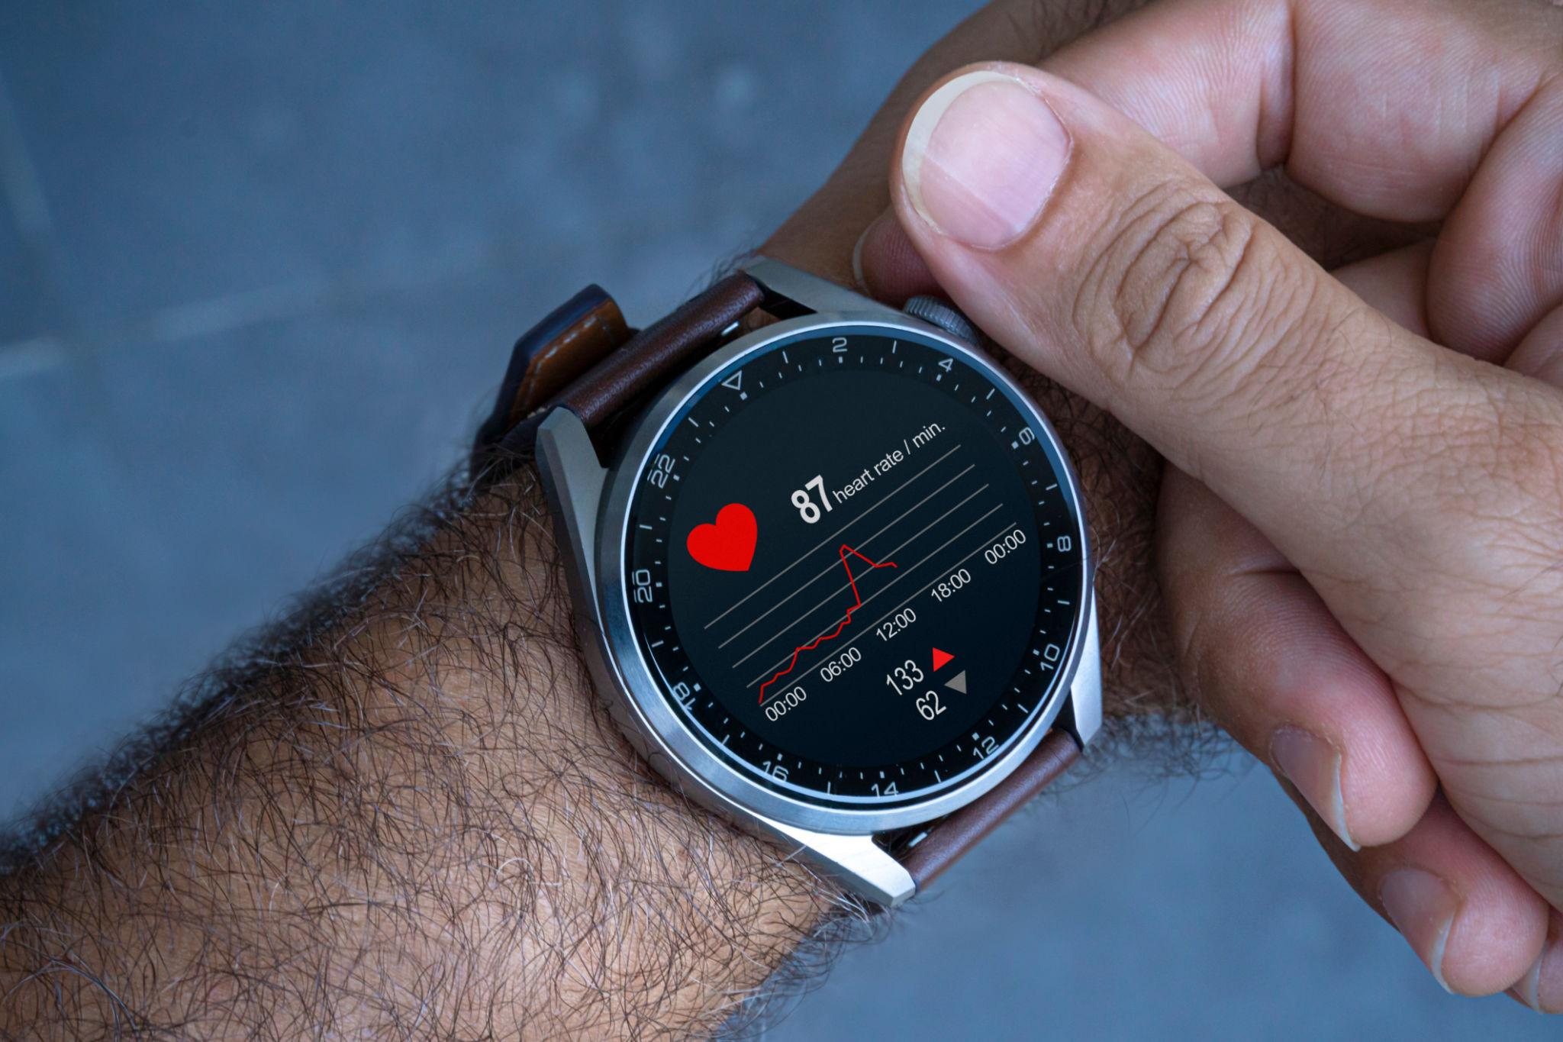
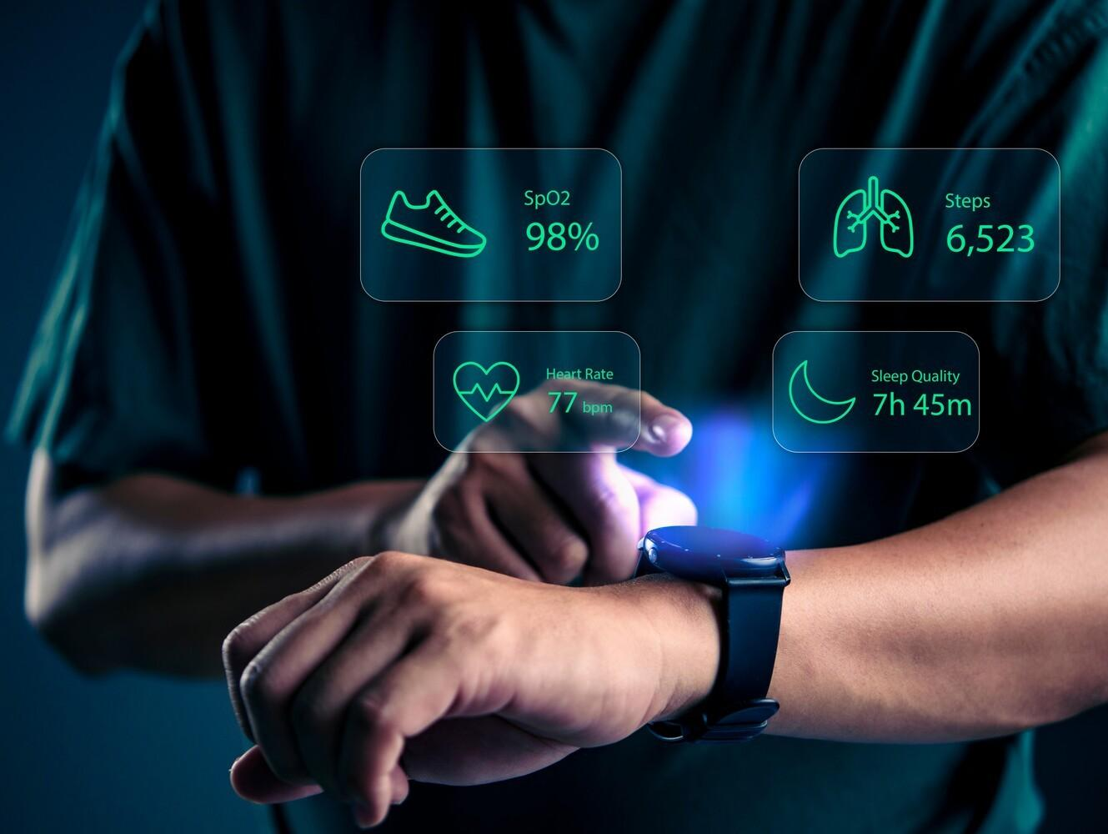
Description
A wearable computer that includes timekeeping plus advanced digital features.
Features
- Notifications
- Heart rate monitoring
- GPS
- Fitness tracking
- Sleep monitoring
- Bluetooth connectivity
Applications
- Health monitoring
- Sports
- Communication
- Navigation

Time Display Formats
# Source: AI Source: Provided by: [Data Path: Persons Table -> ID Column: 1, Name_En Column: Motasem Essam] -> From: [ChatGPT] on [7/17/2026]
Most watches support:
- 12-hour format (AM/PM)
- 24-hour format

Measuring Units
# Source: AI Source: Provided by: [Data Path: Persons Table -> ID Column: 1, Name_En Column: Motasem Essam] -> From: [ChatGPT] on [7/17/2026]
A watch typically displays:
- Hours (h)
- Minutes (min)
- Seconds (s)
Many digital and smartwatches also display:
- Date
- Day
- Month
- Year
- Time zone

Resolution
# Source: AI Source: Provided by: [Data Path: Persons Table -> ID Column: 1, Name_En Column: Motasem Essam] -> From: [ChatGPT] on [7/17/2026]
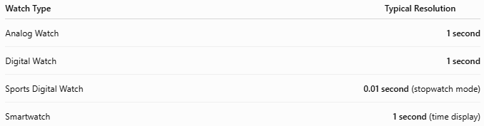
Watch Type | Typical Resolution
Analog Watch | 1 second
Digital Watch | 1 second
Sports Digital Watch | 0.01 second (stopwatch mode)
Smartwatch | 1 second (time display)

How to Read an Analog Watch
# Source: AI Source: Provided by: [Data Path: Persons Table -> ID Column: 1, Name_En Column: Motasem Essam] -> From: [ChatGPT] on [7/17/2026]
- Read the hour hand.
- Read the minute hand.
- Read the second hand (if present).
Example:
- Hour hand between 10 and 11
- Minute hand on 2
- Second hand on 6
Time:
10:10:30

How to Read a Digital Watch
# Source: AI Source: Provided by: [Data Path: Persons Table -> ID Column: 1, Name_En Column: Motasem Essam] -> From: [ChatGPT] on [7/17/2026]
Read the displayed numbers.
Example:
18:42:15
means:
- 18 hours
- 42 minutes
- 15 seconds

Accuracy
# Source: AI Source: Provided by: [Data Path: Persons Table -> ID Column: 1, Name_En Column: Motasem Essam] -> From: [ChatGPT] on [7/17/2026]
Typical accuracy depends on the movement:
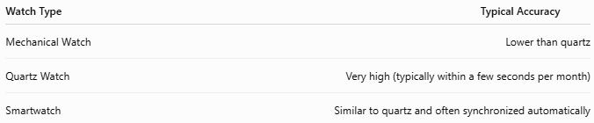
Watch Type | Typical Accuracy
Mechanical Watch | Lower than quartz
Quartz Watch | Very high (typically within a few seconds per month)
Smartwatch | Similar to quartz and often synchronized automatically

Sources of Error
# Source: AI Source: Provided by: [Data Path: Persons Table -> ID Column: 1, Name_En Column: Motasem Essam] -> From: [ChatGPT] on [7/17/2026]
Mechanical Errors
- Worn gears
- Spring fatigue
- Shock damage

Electronic Errors
- Weak battery
- Quartz aging
- Electronic malfunction

Environmental Errors
- Extreme temperatures
- Strong magnetic fields (especially for some mechanical watches)
- Moisture (if not water-resistant)

User Errors
- Incorrect time setting
- Forgetting to adjust after battery replacement
- Ignoring time-zone changes

Applications
# Source: AI Source: Provided by: [Data Path: Persons Table -> ID Column: 1, Name_En Column: Motasem Essam] -> From: [ChatGPT] on [7/17/2026]
Watches are used in:
- Daily life
- Business
- Sports
- Military
- Aviation
- Medicine
- Engineering
- Scientific research
- Outdoor activities

Advantages
# Source: AI Source: Provided by: [Data Path: Persons Table -> ID Column: 1, Name_En Column: Motasem Essam] -> From: [ChatGPT] on [7/17/2026]
A watch:
- Is portable.
- Provides instant access to the current time.
- Helps manage schedules.
- Offers additional features such as alarms and stopwatches.
- Smartwatches provide health monitoring and communication features.

Limitations
# Source: AI Source: Provided by: [Data Path: Persons Table -> ID Column: 1, Name_En Column: Motasem Essam] -> From: [ChatGPT] on [7/17/2026]
A watch:
- Battery-powered models require battery replacement or charging.
- Mechanical watches require periodic servicing.
- Smartwatches have limited battery life compared to traditional watches.
- Advanced features vary by model.

Comparison with Other Time Measuring Instruments
# Source: AI Source: Provided by: [Data Path: Persons Table -> ID Column: 1, Name_En Column: Motasem Essam] -> From: [ChatGPT] on [7/17/2026]
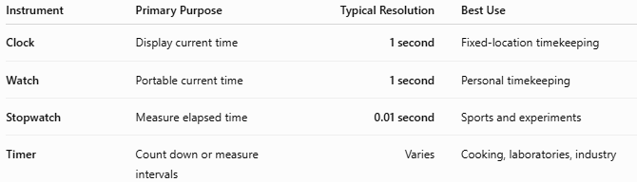
Instrument | Primary Purpose | Typical Resolution | Best Use
Clock | Display current time | 1 second | Fixed-location timekeeping
Watch | Portable current time | 1 second | Personal timekeeping
Stopwatch | Measure elapsed time | 0.01 second | Sports and experiments
Timer | Count down or measure intervals | Varies | Cooking, laboratories, industry

Care and Maintenance
# Source: AI Source: Provided by: [Data Path: Persons Table -> ID Column: 1, Name_En Column: Motasem Essam] -> From: [ChatGPT] on [7/17/2026]
To maintain accuracy:
- Replace batteries when needed (quartz watches).
- Wind mechanical watches regularly if required.
- Recharge smartwatches as recommended.
- Keep the watch clean.
- Avoid strong impacts.
- Service mechanical watches periodically.
- Ensure water-resistant models have properly sealed gaskets.

Common Mistakes
# Source: AI Source: Provided by: [Data Path: Persons Table -> ID Column: 1, Name_En Column: Motasem Essam] -> From: [ChatGPT] on [7/17/2026]
- Confusing 12-hour and 24-hour formats.
- Forgetting to adjust the date after months with fewer than 31 days (on non-perpetual calendars).
- Exposing non-waterproof watches to water.
- Allowing smartwatch batteries to remain fully discharged for extended periods.

Key Points
# Source: AI Source: Provided by: [Data Path: Persons Table -> ID Column: 1, Name_En Column: Motasem Essam] -> From: [ChatGPT] on [7/17/2026]
- A Watch is a portable time-measuring instrument.
- Common types:
  - Analog Watch
  - Digital Watch
  - Mechanical Watch
  - Quartz Watch
  - Smartwatch
- Most watches display:
  - Hours
  - Minutes
  - Seconds
- Quartz watches are the most common due to their accuracy and affordability.
- Smartwatches extend traditional timekeeping with health monitoring, communication, GPS, and fitness tracking.

Conclusion
# Source: AI Source: Provided by: [Data Path: Persons Table -> ID Column: 1, Name_En Column: Motasem Essam] -> From: [ChatGPT] on [7/17/2026]
A Watch is one of the most practical and widely used time-measuring instruments, providing continuous access to the current time in a portable form. From traditional mechanical and analog watches to highly accurate quartz watches and multifunctional smartwatches, these devices have evolved far beyond simple timekeeping. Today, watches serve not only as essential tools for personal time management but also as devices for health monitoring, communication, navigation, and productivity, making them indispensable in both everyday life and professional environments.

